**Ideation Phase**

**Empathize & Discover**

|  |  |
| --- | --- |
| Date | 01 October 2025 |
| Team ID | **SWUID20250216599** |
| Project Name | Smart Meet |
| Maximum Marks | 4 Marks |

**Empathy Map Canvas:**

Understand the needs, frustrations, and behaviours of meeting professional

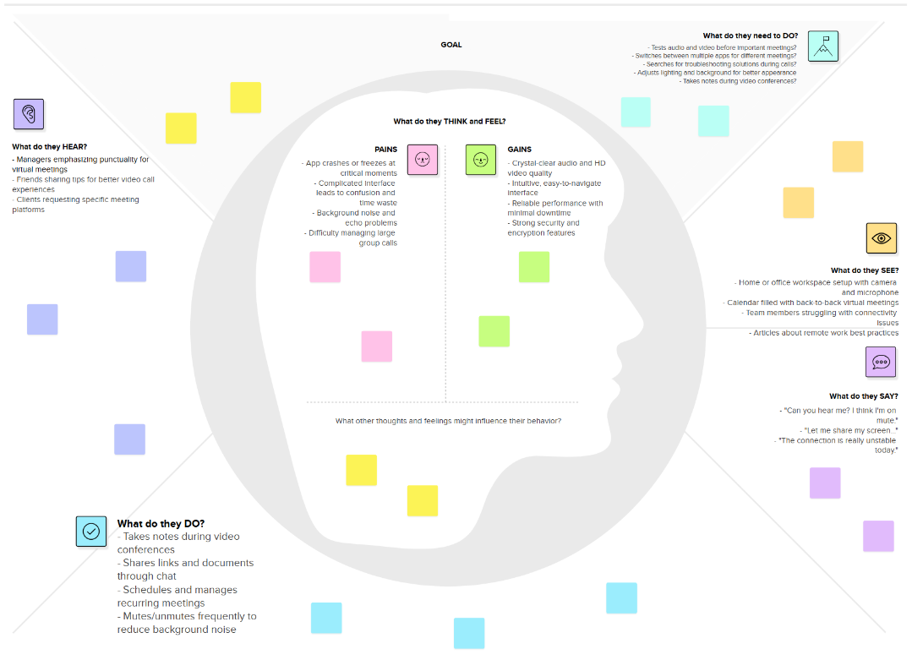Seeking consistent work through a platform like Smart Meet.